Socket Programming Project:
A Multi-Client Chat Application

Robert Benstine & Chris Cartaya
Florida Gulf Coast University
COP 3635 - Systems and Networks
Dr. Deepa Devasenapathy
April 14, 2026

Important Links

GitHub Repo - https://github.com/Robert12905/Socket-Programming

YouTube video link - https://www.youtube.com/watch?v=Stl3UEJrTO0

Presentation (Google Slides) - https://docs.google.com/presentation/d/1fn--jBDqjoZhdeGHb59eJXN4JT56yFMc30B4Y2QDSnw/edit?usp=sharing

Content Overview
- Project Objective
- Networking Layers & Tools Used
- Important Socket Functions
- Flow Diagram of Network Architecture
- Cisco Packet Tracer Diagram
- Link to Video Demo
- Python Code
- Sample Output
- Team Member Contribution
- Challenges
- Future Improvements
- Conclusion & What We Learned

Project Objective
The objective of this project is to design and develop a multi-client chat application using socket programming. The system will follow a client-server architecture, where multiple clients can connect to a central server and communicate in real time.
This project aims to demonstrate how networked applications enable communication between devices by allowing programs to send and receive data over TCP connections. The application will support real-time message exchange between multiple clients through the server.
Key goals of the project include:
- Establishing connections between multiple clients and a central server
- Enabling real-time communication and message broadcasting
- Implementing data transmission using TCP sockets
- Demonstrating core networking concepts such as client-server communication and connection handling

Network Layers & Tools Used
This project utilizes key networking layers and tools to enable reliable communication between multiple clients and a central server.

Network Layers
- Transport Layer (TCP) - Layer 4
  - Ensures reliable, ordered, and error-checked data transmission between clients and server
- Network Layer (IPv4) - Layer 3
  - Handles logical addressing and routing of data across the network

Together, these layers enable efficient and reliable communication within the client-server architecture.

Tools
- Python 3.13+
- Python Socket Library (built-in socket module for network communication)
- Virtual Environment (.venv) for dependency and project isolation

Important Socket Functions
This image highlights the core socket functions used in this project. These functions form the foundation of client-server communication, allowing clients to connect to the server, send and receive messages, and maintain active network connections.

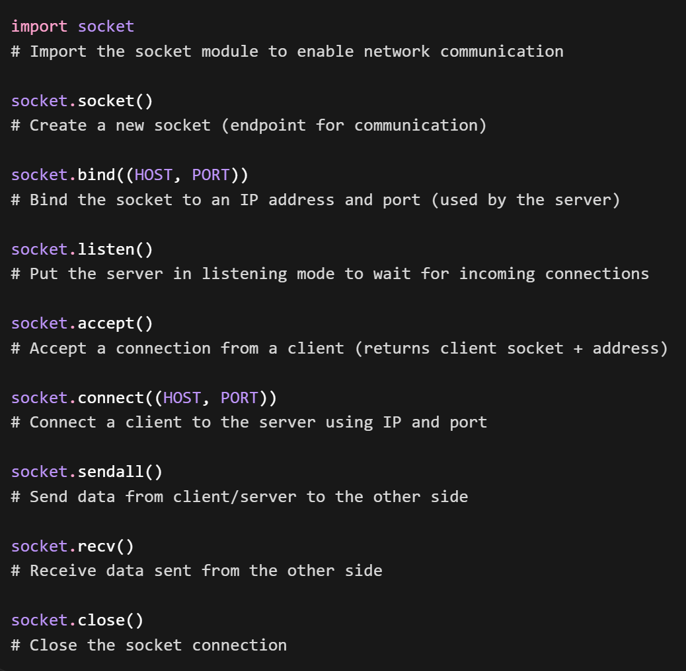

Flow Diagram of Network Architecture
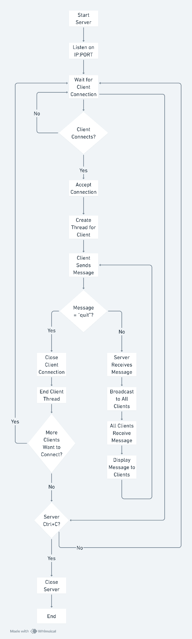

Cisco Packet Tracer Diagram
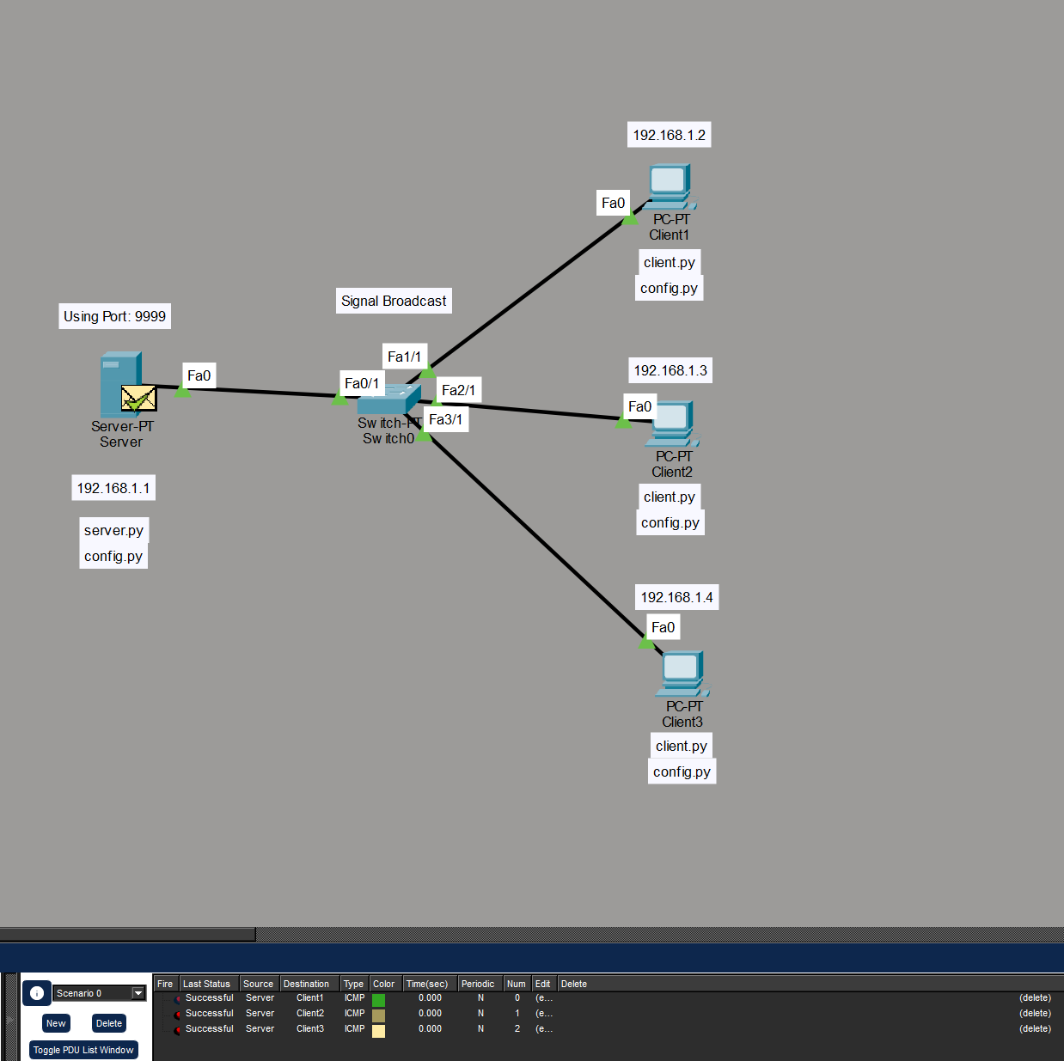

Link to Video Demo
Socket Programming Code Demo | Systems & Networks

Python Code

File: config.py
Stores shared configuration values such as host, port, buffer size, and encoding.
This allows both the client and server to use the same settings without duplicating code.

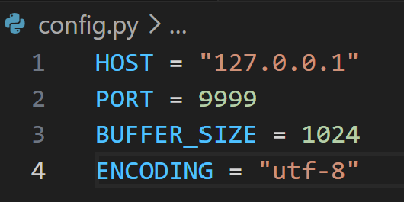

File: server.py
Runs the server. Handles client connections, message broadcasting, usernames, and server-side validation logic.

import socket
import threading

from config import HOST, PORT, BUFFER_SIZE, ENCODING

clients = []
usernames = {}
clients_lock = threading.Lock()

def broadcast_message(message: str, sender_socket: socket.socket | None = None) -> None:
"""Send a message to all connected clients except the sender, if provided."""
with clients_lock:
disconnected_clients = []

for client_socket in clients:
if sender_socket is not None and client_socket is sender_socket:
continue

try:
client_socket.sendall(message.encode(ENCODING))
except OSError:
disconnected_clients.append(client_socket)

for client_socket in disconnected_clients:
if client_socket in clients:
clients.remove(client_socket)
usernames.pop(client_socket, None)
client_socket.close()

def remove_client(client_socket: socket.socket) -> None:
"""Remove a client socket from the active clients list and username mapping."""
with clients_lock:
if client_socket in clients:
clients.remove(client_socket)
usernames.pop(client_socket, None)

def handle_client(client_socket: socket.socket, client_address: tuple[str, int]) -> None:
"""Handle communication with one connected client."""
print(f"[NEW CONNECTION] {client_address} connected.")

username = f"Client {client_address[1]}"

try:
received_username = client_socket.recv(BUFFER_SIZE).decode(ENCODING).strip()
if received_username:
username = received_username
else:
username = "Anonymous"

with clients_lock:
if username in usernames.values():
client_socket.sendall(
"[ERROR] Username already taken. Please choose a different username.".encode(ENCODING)
)
print(f"[REJECTED] {client_address} tried duplicate username '{username}'.")
client_socket.close()
return

clients.append(client_socket)
usernames[client_socket] = username

client_socket.sendall("[SERVER] Username accepted.".encode(ENCODING))
print(f"[USERNAME] {client_address} is using username '{username}'.")
broadcast_message(f"[SERVER] {username} joined the chat.", client_socket)

while True:
message = client_socket.recv(BUFFER_SIZE).decode(ENCODING)

if not message:
print(f"[DISCONNECTED] {username} disconnected.")
broadcast_message(f"[SERVER] {username} left the chat.", client_socket)
break

cleaned_message = message.strip()
formatted_message = f"{username}: {cleaned_message}"

print(f"[RECEIVED] {formatted_message}")
broadcast_message(formatted_message, client_socket)

except ConnectionResetError:
print(f"[DISCONNECTED] {username} disconnected.")
broadcast_message(f"[SERVER] {username} left the chat.", client_socket)

except OSError:
print(f"[DISCONNECTED] {username} disconnected.")
broadcast_message(f"[SERVER] {username} left the chat.", client_socket)

except Exception as error:
print(f"[ERROR] Unexpected error with {client_address}: {error}")

finally:
remove_client(client_socket)
client_socket.close()
print(f"[CLOSED] Connection with {client_address} closed.")

def start_server() -> None:
"""Start the socket server and listen for incoming client connections."""
server_socket = socket.socket(socket.AF_INET, socket.SOCK_STREAM)
server_socket.bind((HOST, PORT))
server_socket.listen()

# Prevent accept() from blocking forever, allowing Ctrl+C to be handled
server_socket.settimeout(1.0)

print(f"[LISTENING] Server is listening on {HOST}:{PORT}")

try:
while True:
try:
client_socket, client_address = server_socket.accept()

client_thread = threading.Thread(
target=handle_client,
args=(client_socket, client_address),
)
client_thread.start()

print(f"[ACTIVE CLIENTS] {threading.active_count() - 1}")

except socket.timeout:
pass

except KeyboardInterrupt:
print("\n[SHUTDOWN] Server is shutting down.")

finally:
with clients_lock:
for client_socket in clients:
try:
client_socket.shutdown(socket.SHUT_RDWR)
except OSError:
pass
finally:
client_socket.close()

clients.clear()
usernames.clear()

server_socket.close()

if __name__ == "__main__":
start_server()

File: client.py
Connects to the server. Sends user input and receives messages from the server.
This single file can be run multiple times (in separate terminals) to simulate multiple clients.

import socket
import threading

from config import HOST, PORT, BUFFER_SIZE, ENCODING

def receive_messages(client_socket: socket.socket, connection_closed: threading.Event) -> None:
"""Continuously receive messages from the server."""
try:
while True:
message = client_socket.recv(BUFFER_SIZE).decode(ENCODING)

if not message:
if not connection_closed.is_set():
print("[DISCONNECTED] Server closed the connection.")
connection_closed.set()
break

print(message)

except (ConnectionResetError, OSError):
if not connection_closed.is_set():
print("[DISCONNECTED] Server closed the connection.")
connection_closed.set()

except Exception as error:
if not connection_closed.is_set():
print(f"[ERROR] Unexpected receive error: {error}")
connection_closed.set()

finally:
client_socket.close()

def start_client() -> None:
"""Connect to the server and allow the user to send messages."""
client_socket = socket.socket(socket.AF_INET, socket.SOCK_STREAM)
client_socket.connect((HOST, PORT))

username = input("Enter username: ").strip()
if not username:
username = "Anonymous"

client_socket.sendall(username.encode(ENCODING))

server_response = client_socket.recv(BUFFER_SIZE).decode(ENCODING)

if server_response.startswith("[ERROR]"):
print(server_response)
client_socket.close()
return

print(f"[CONNECTED] Connected to server at {HOST}:{PORT}")
print("Type messages and press Enter to send.")
print("Type 'quit' to disconnect.\n")

connection_closed = threading.Event()

receive_thread = threading.Thread(
target=receive_messages,
args=(client_socket, connection_closed),
daemon=True,
)
receive_thread.start()

try:
while True:
user_input = input()

if connection_closed.is_set():
break

if user_input.strip().lower() == "quit":
print("[DISCONNECTING] Closing connection...")
break

client_socket.sendall(user_input.encode(ENCODING))

except KeyboardInterrupt:
print("\n[DISCONNECTING] Client interrupted by user.")

except OSError:
if not connection_closed.is_set():
print("[DISCONNECTED] Connection to server was lost.")
connection_closed.set()

except Exception as error:
if not connection_closed.is_set():
print(f"[ERROR] Unexpected send error: {error}")
connection_closed.set()

finally:
try:
client_socket.shutdown(socket.SHUT_RDWR)
except OSError:
pass
finally:
client_socket.close()

if __name__ == "__main__":
start_client()

Sample Output

Fullscreen
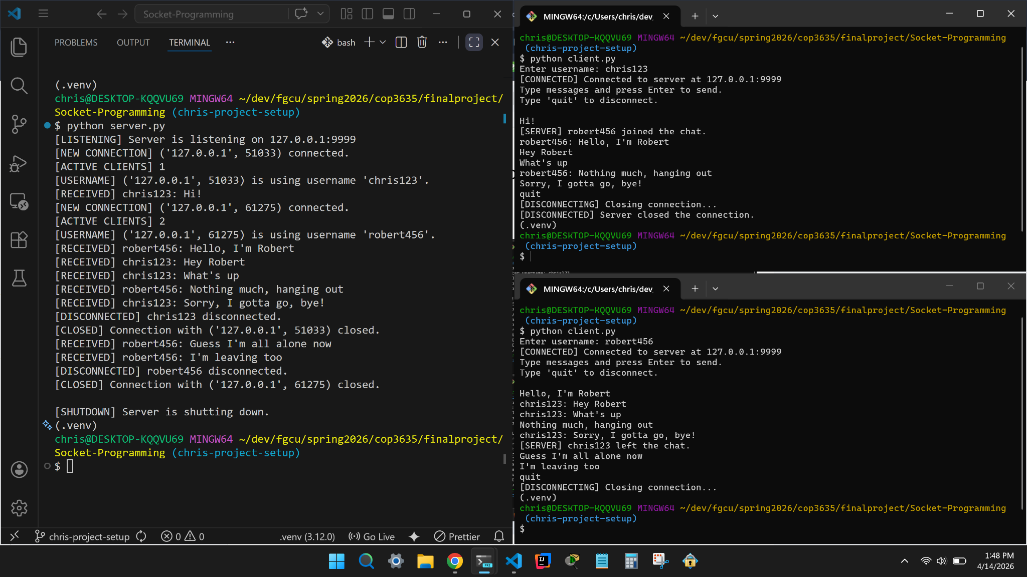

Detailed views are below.

Terminal 1 (Server)

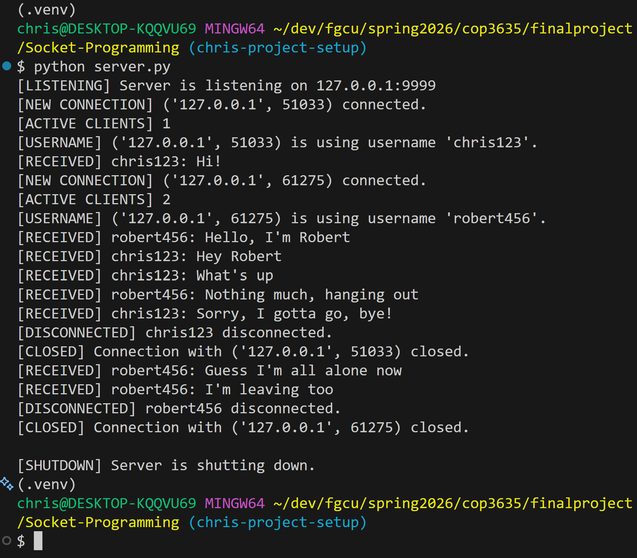

Terminal 2 (Client 1)

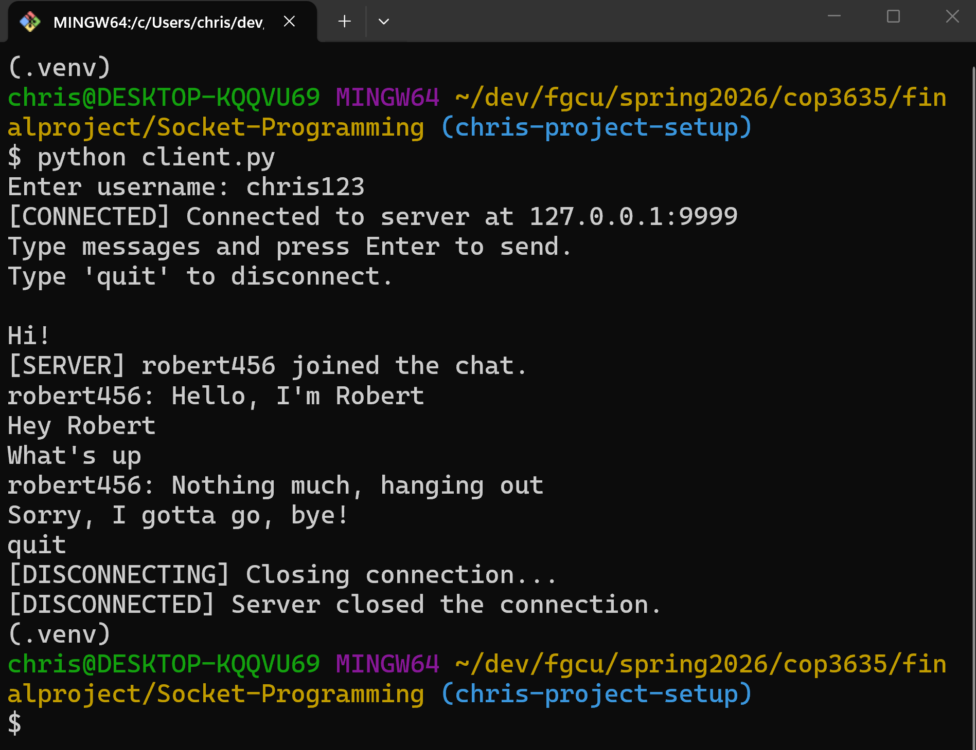

Terminal 3 (Client 2)

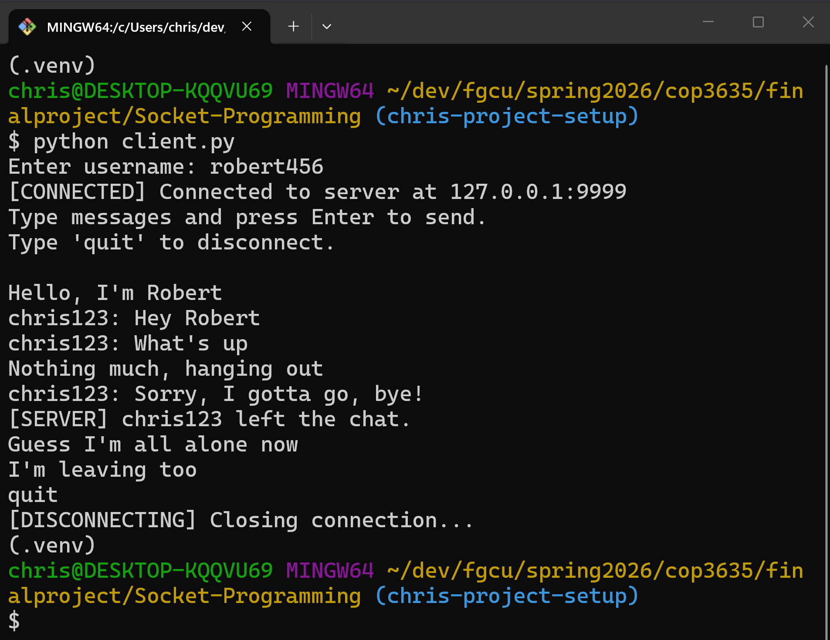

Team Member Contributions
- Robert
  - Foundational Socket Program Code
  - Cisco Packet Tracer setup
  - Presentation FoundationFormat
  - Code - Video Demonstration
  - Github Oversight - Experimental Features
- Chris
  - Implemented core functionality of multi-client application
  - Added features:
    - Join / leave notifications
    - Duplicate username protection
    - Graceful disconnect handling
  - Revised presentation slides
  - Created flow diagram for network architecture

Challenges
- Knowing how and when to use Python socket functions
- Learning how to go from a one-client/one-server model to a multi-client model with “threading” → remembering OS concepts
  - Daemon thread vs non-daemon thread
- Understanding why the server showed different port numbers when connected to a client → ephemeral ports
  - Assigned by OS to client app for outgoing connections
  - Like a “return address”

Future Improvements
- Each user is designated a specific chatter-color
  - Improved UX
- Retry username selection without disconnecting
  - Account integration?
- Timestamps for messages
- Private (Direct) messaging
- Active user list command (e.g. /users )
- Remote Server Connection
  - Save back-end activity and safer UX
- Add a GUI for a chat room

Conclusion & What We Learned
- Gained hands-on experience with socket programming
- Improved understanding of client-server communication
- Learned how networking protocols enable real-time systems
- Demonstrated a practical networking application

